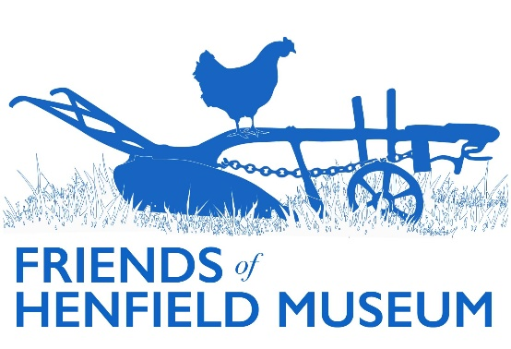

Friends Update

May 2024

AGM held: enjoyable talk by Peter Bates on Farming in the ‘40s and ‘50s.

Committee re-elected, minus David Smith and Leo Jago. Peter Bates elected Vice Chair.

Mudlarks in Henfield: a very successful event in collaboration with Graham duHeaume and London mudlarks, with over 300 visitors during the day, a decent profit turned, the talk oversubscribed (over 100) and several new Friends gained.

3D scanning of the next three objects (Wilberforce Waistcoat, 13th century lead weight, early Anglo-Saxon silver ring) now completed and objects back in museum. Uploading these larger files will have some additional cost.

Palstave axe head and hoard returned from Exeter Uni along with student’s pXRF report on chemical composition. Next steps: cleaning of bronze disease/patina, hopefully at East Dean, re XRF to compare with prior results, and ideally scan Maggie Parnell’s additional locally found partial palstave as point of comparison.

Website updated in various places inc. Arborea, Friends page, Marjorie Baker Collection, Historic Photo collection.

Marjorie Baker collection: two images of RAF and ‘Carry On’ veteran Talbot Rothwell restored, uploaded and shared on socials. All MB photos from 1932-1953 uploaded and now accessible from the museum Google Drive.

Partial article on Woodard received from Lancing student.

Roving Display Case due to move from Free Church to Library with current Devil’s Dyke display.

Oral Histories: call out in recent magazines for new volunteers to interview and/or edit.

Borrer Transcription project: accepting new transcription volunteers now.

Summer Fair – table to be shared with History Group, quoits to be available.

