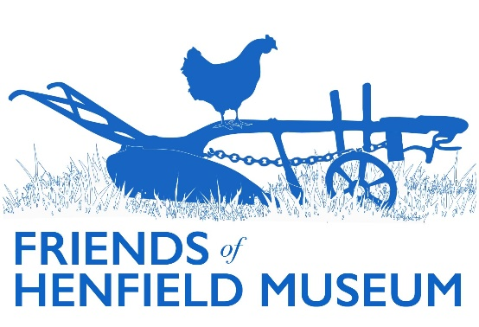

Friends Update

*August 2024*

*General*

* Membership: the renewals process is now nearly complete and our new Treasurer has had time to bed in post. We currently have 82 paid members total, including a mixture of individual (£10) and family (£15, two people). This equates to 123 Friends total.
* Merchandise: decent sales of greeting cards, books, prints, with resultant healthy budget at end of membership renewal period of: £5695.27.
* Website: museum website hosting renewed/paid for another two years from Friends funds. Contant updated in various places inc. Arborea, Historic Photo collection, Oral Histories, Marjorie Baker collection. [Website analytics](https://docs.google.com/spreadsheets/d/1jLW4bBTGbHKTo2nUY-BAVvnbVkyDn_LA/edit?usp=sharing&ouid=104915441849188783759&rtpof=true&sd=true). Blog articles (in aggregate) continue to be the most popular area - 269 visits to these in July.
* Roving Display Case due to move from Library to Haven with current Devil’s Dyke display. Possibility of a temporary WW2 display in Henfield Hall foyer in collaboration with Henfield Theatre Company’s upcoming *Goodnight Mr. Tom* production – objects/photos/production posters. Confirmed still no possibility of St. Peter’s Church hosting. Currently operating at minimum viable number of venues.

*Events*

* Summer Fayre: a successful if initially blustery quoits pitch/display run and publicised after on social media. A new gazebo now being sourced...
* Summer visit: now scheduled for 24th September – a Shoreham Airport tour and terminal lunch.
* Christmas Charities Fair, 9th Nov: Friends/museum table booked in main hall.
* Christmas party: to be confirmed for 4th December.

*Research*

* New works on the Allen-Brown violet nurseries have recently been published, both featuring photos from the museum collection after their authors contacted the museum. Rebecca Welshman’s article in Gardening Magazine: *Violets, suffragettes and socialist gardening…* & the relevant chapter in Fiona Davison’s *An Almost Impossible Thing*.
* Borrer: in communication with researcher on William Hemsley (Richard Mithen) who recently visited the museum. A couple of references unearthed via his research will be added to the website Borrer profile article.

*Projects*

* 3D scanning project: the application process for a wider project via lottery grant in collaboration with 3Dify Brighton can begin when time available to write the application. 10-20k grant, ideally match funded 10% by Friends funds and/or labour equivalent. The aim to be ~100 representative objects scanned with a public Museum/3Dify event to mark completion. Object nominations are now needed. Criteria could include one or more of rarity, popularity (see existing Favourite Object project etc.), suitability for scanning/viewing from multiple angles, object delicacy preventing physical display, associated stories etc. Potential to engage public/school in nomination process. Costs to cover 3D scanning, completion event, transport/fuel, SketchFab hosting fees, additional labour if necessary.
* Display boards: Berrett’s suggested an amended version of Leo’s original board including more railway facts and a more railway relevant oral history/photo. Changes to be made and resent in due course.
* Leo’s history boxes used 10 or so years ago in shops – hope to give them another run given shop turnover since then.
* Borrer Transcription project: several transcribed letters double checked; others sent out to several volunteers.