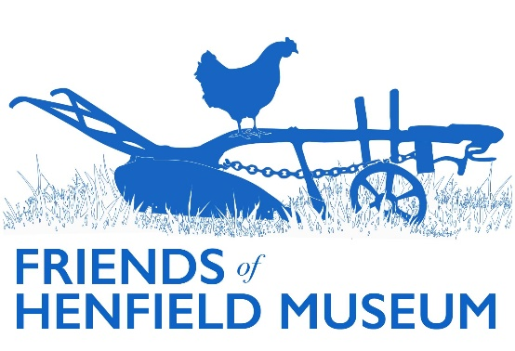

Friends Update

*November 2024*

*General*

* Membership: we currently have 90 paid up memberships total, including a mixture of individual (£10) and family (£15, two people) and 7 life. This equates to 118 Friends total.
* Merchandise: good sales of greeting cards, books, prints at the Charities Fair, with resultant healthy budget of: £5695.27 as of October. An amended greeting card set featuring just the popular Golden Square image to go on sale shortly.
* Website: content updated in various places inc. Art Collection, Historic Photo collection, ‘Those Who Served’ (Marjorie Baker collection), Henfieldians Past (Bob Ward + Nathaniel Woodard). View [website analytics](https://docs.google.com/spreadsheets/d/1jLW4bBTGbHKTo2nUY-BAVvnbVkyDn_LA/edit?usp=sharing&ouid=104915441849188783759&rtpof=true&sd=true). Blog articles (in aggregate) continue to be the most popular area.
* Social media: posts included a restored Marjorie Baker photo of Walter Rayment to coincide with Remembrance, costume posts, expanded Cat House article link, Scouts visit photos, Tracing the Rails visit notice, restored painting of the Plough c. 1860, handbell ringers, restored/colourised photo of Parsonage Farm lane in 1896, mudlark talk photos.
* Roving Display Case moving from the Library for a brief stint at the Henfield Haven for the end of the Devil’s Dyke display, the case moved to Henfield Hall for first time in several years with a new WW2 display in collaboration with Henfield Theatre Company’s upcoming *Goodnight Mr. Tom* production – objects/photos/production posters. This makes brings the number of venues to a more healthy four.

*Events*

* Summer visit: the Shoreham Airport tour was popular enough to do two visits and went down well.
* Christmas Charities Fair, 9th Nov: see merchandise above – fair seemed well attended.
* Christmas party: confirmed for 4th December with Peter Bates speaking on theatre in Henfield.

*Research*

* Article on Cat House/Ward/Woodard published in Sept Parish Magazine and subsequently on museum blog.
* Article on Redwood Renaissance/Project Arborea published in Nov BN5 Magazine and to be published on Arborea/museum blog.
* Glasby drawings: communication had with church in Atlanta re. their 100th anniversary – their stained glass are Glasby windows. Some drawings and cartoons in museum collection. Most (115) of the large format cartoon drawings for the church windows were donated by Lucie Bishop (after she received them in Dulcima Glasby’s will) to the Atlanta Historical Society in 1976 after several were exhibited at Henfield Museum in 1975. This was a major donation valued at $10k in 1976; trying to establish if they have been exhibited in Atlanta since. Art Collection webpage updated with photos taken of Glasby drawings.
* Visit to local farm to view hidden hoard of 18th-19th century shoes and other items (see Costume Curator’s report). To be publicised on social media.
* Discussion/research ongoing into local paintings of Woodmancote martyrs burned at the stake.

*Projects*

* 3D scanning project: the application process for a wider project via lottery grant in collaboration with 3Dify Brighton can begin when time available to write the application (see Aug update for details). Shared submission draft doc now created by 3Dify.
* Oral Histories: three new volunteers taken on as a result of social media post, with renewal meeting held, documentation subsequently reviewed for update, cloud storage area on museum Google Drive arranged/ordered, older files uploaded and initial interviewees for new volunteers set.
* Display boards: Berrett’s suggested an amended version of Leo’s original board including more railway facts and a more railway relevant oral history/photo. Changes to be made and resent in due course.
* Borrer Transcription project: several transcribed letters double checked; others sent out to several new volunteers.
* Digitisation: initial scoping meeting had with Max Communications for Stage 2, planned for April 2025 when PC funding available (in combination with Friends funding half).