**HENFIELD COMMONS JOINT COMMITTEE AGENDA**

Notice of a meeting of the **Henfield Commons Joint Committee** to be held at **10-00am on** **10/03/24 at Henfield Club, Cagefoot Lane, Henfield.**

**Members:** Cllrs.Gill Perry (chair), Roger Noel, Josh Potts, Andrea May

Tony Baker, Eddie Colgate, John Willis (non-voting members)

**Officers:** Pete Crawford, Malin Andersson, Jake Everitt, Neal Matheson

1. **DECLARATION OF MEMBERS INTERESTS:**
2. **APOLOGIES**
3. **APPROVAL OF MINUTES OF 02/12/24**
4. **CHAIRMAN’S ANNOUNCEMENTS**
5. **MATTERS ARISING**
6. **OPEN FORUM** – Opportunity for members of the public to speak
7. **TANYARD**

* Hedges
* Tanyard Barn use

1. **HENFIELD COMMON**

* Ash dieback works
* Horse barrier
* Henfield Village Fair
* Swains Planning application
* Circus 2026
* Gas pipeline
* Current works

1. **BROADMARE COMMON**
2. **OREHAM COMMON**
3. **CORRESPONDENCE**
4. **BUDGET/EXPENDITURE**
5. **ANY OTHER BUSINESS**

**DATE OF NEXT MEETINGS –** TBC- All meetings to start at 10-00am and take place at the Henfield Club (tbc)

**Additional Notes:**

8. Henfield Common

Suggested replacement of Horse barrier from WSCC ROW

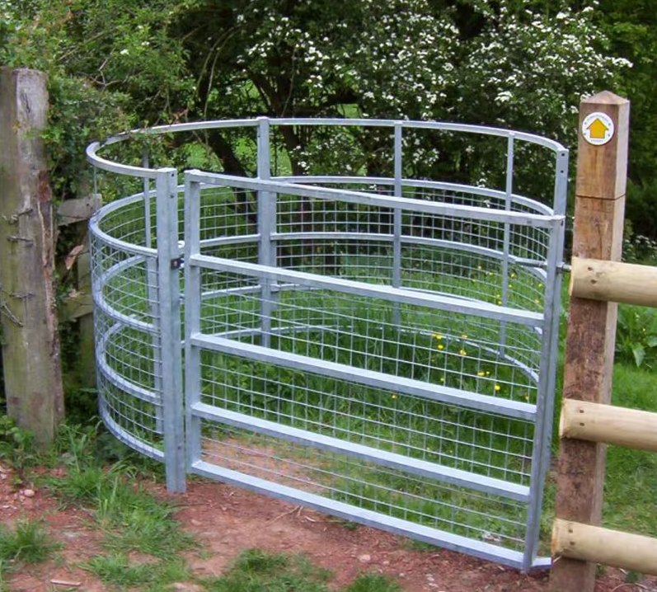

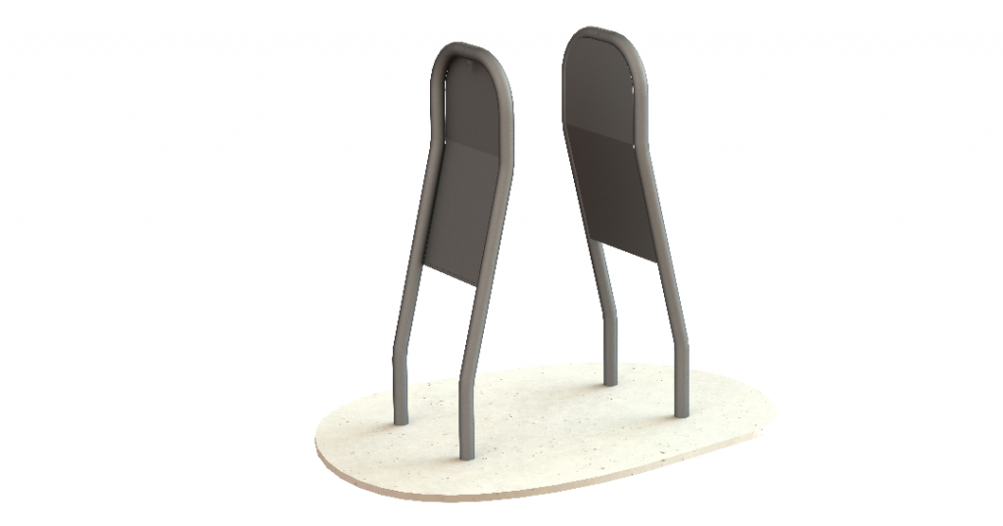

Possible alternative? Supplier: Centrewire

12. Budget 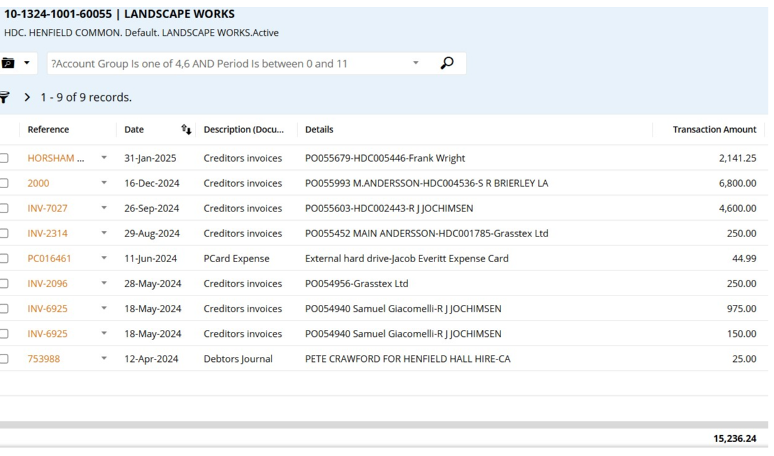

Expenditure of £15,236 as shown above, offset by £500 from the Fair, means there is still £4544 remaining.

Expenditure still to come c£800 for the Tanyard mgt plan, cost of kissing gate at Henfield and a new gate for Tanyard, c £2000 for both. Any remaining monies can be used to offset cost of ash die back works.