Linda Cook
12 Richmond Close
Market Weighton
YO433EX

HedgehogsRus@mail.com
Firstly, thank you for taking the time to read this letter!
I am writing to all Councils, Parishes, Towns and Wards in the UK to ask them to take part in this amazing project!
Hedgehogs R Us Highway Project

With Hedgehog numbers in decline and Hedgehog awareness on the rise, there has never been a better time to get involved in Hedgehog conservation.

A Hedgehog Highway is a 5 inch gap in a fence and is essential in the battle to prevent the extinction of our endangered spiky friends. This gap allows them access to forage for food and meet mates.

Hedgehog shaped fence surrounds raise awareness to the plight of Hedgehogs, create a talking point and encourage others to take part in the project. Fence surrounds are made from recycled plastic and can themselves be recycled.

I am asking for each area of the UK to use a small portion of their assigned funds to purchase a box of hedgehog highway surrounds and make them available for their residents.

Each box of 50 is £150 and includes:
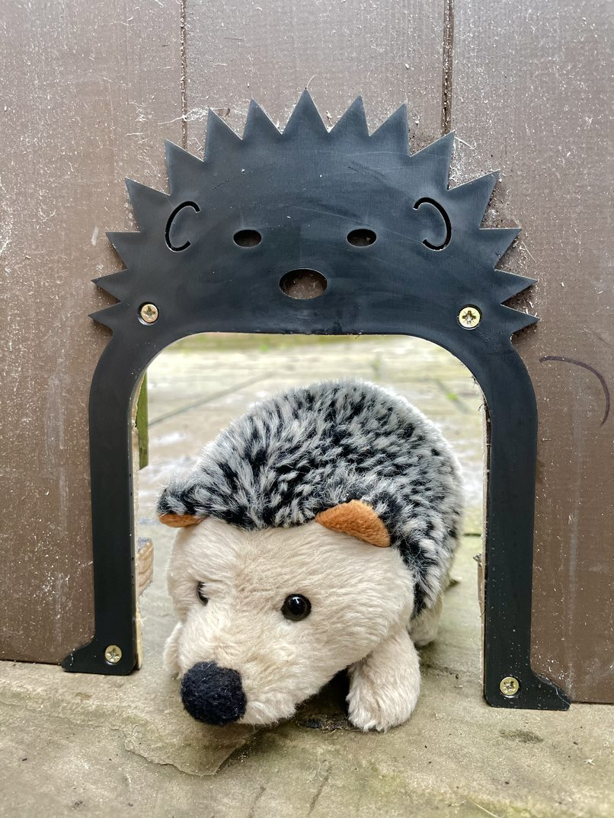
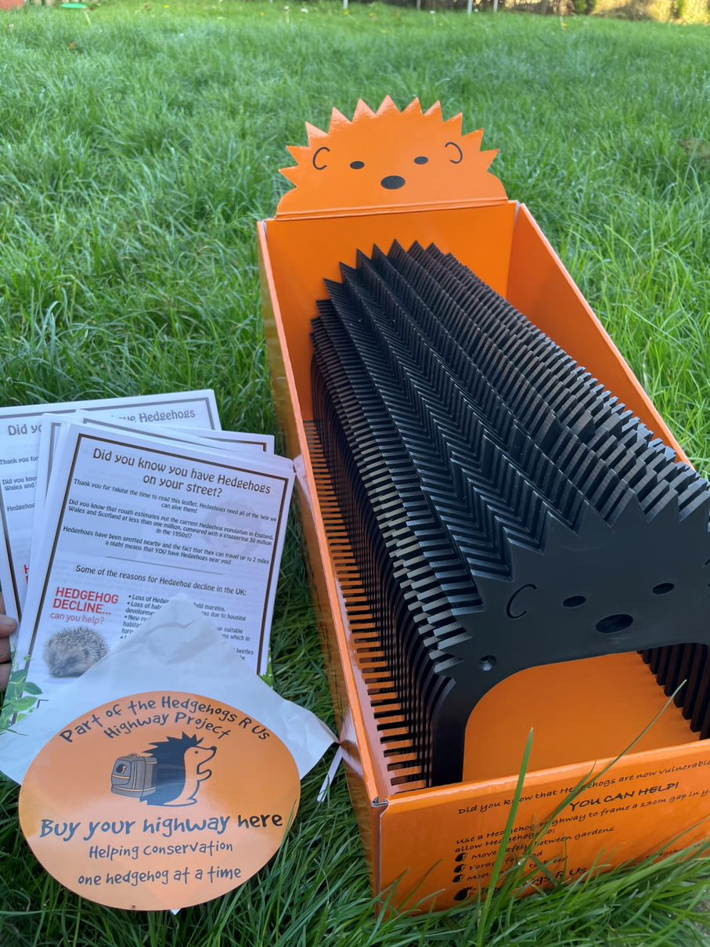
* 50 Hedgehog Highway surrounds & 50 information leaflets
*A display box & window sticker showing you are part of the project.

Ideas of how to benefit your community include:
*Donate the Highways and leaflets to your local school to educate in wildlife conservation
*Swap the Highways for a donation of Hedgehog food which can then be given to your local Hedgehog Rescue Centre

The project will be receiving a lot of publicity in the coming months via Social Media and I really hope that you choose to take part.

My dream is to make the whole of the UK one giant Hedgehog Highway and for that dream to come true, it needs EVERYONE to take part.

Money is donated to Hedgehog Conservation for every box sold too!

If you would like to order or have any questions please do not hesitate to get in touch and thank you for caring.
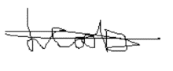

Linda Cook, Founder of Hedgehogs R Us

